**Request / Response Format**

The following are the Request and Response format of the bot:

**Request payload when a visitor lands on the website**

|  |  |  |
| --- | --- | --- |
| **Inputs** | **Type** | **Description** |
| visitor | Map | Details of the website visitor |
| handler | String | A trigger handler is initiated (Value: trigger) |
| org_id | String | Which will contain the org ID of the portal |
| request | Map | Details of the chat message request |

|  |  |  |
| --- | --- | --- |
| **Inputs** | **Type** | **Description** |
| message | Map | Details of the message in the conversation (Attribute: text) |
| visitor | Map | Details of the website visitor |
| operation | String | Details of the operations happen during the chat conversation (values: chat, message)  chat -For the first message of the visitor  message - For subsequent replies from visitor |
| handler | String | The message handler is initiated (Value : message) |
| org_id | String | Which will contain the org ID of the portal |
| request | Map | Details of the chat message request |
| attachments | Array | List of files attached in the chat message request.  **Note**: If this is not added, an empty array will be returned. |

**Request payload when a context gets completed**

|  |  |  |
| --- | --- | --- |
| **Inputs** | **Type** | **Description** |
| answers | String | Details of the message in the conversation (Attribute: text) |
| visitor | Map | Details of the website visitor |
| context_id | String | ID of the context currently used |
| handler | String | The context handler is initiated (Value : context) |
| org_id | String | Which will contain the org ID of the portal |

**Visitor Objects Format:**

The visitor object is a map containing the profile information of the website visitor. [Learn More](https://www.zoho.com/salesiq/help/developer-section/deluge-object-reference-visitor.html)

**Attachment Object format**

The attachment is a collection object, which contains the files that are shared by the visitor during the conversation as a message. [Learn More](https://www.zoho.com/salesiq/help/developer-guides/deluge-object-reference-attachment.html)

**Message Object Format**

Each text message in the conversation will be considered as the message object. [Learn More](https://www.zoho.com/salesiq/help/developer-section/deluge-object-reference-message.html)

**Response format**

The input and output responses given by the bot during the conversation. [Learn More](https://www.zoho.com/salesiq/help/developer-section/deluge-object-reference-responses.html)

**Visitor**

The **visitor** object is a map containing the profile information of the website visitor.

The visitor object contains the following properties:

|  |  |
| --- | --- |
| **Attributes** | **Description** |
| name | The name of the visitor. |
| email | The email address of the visitor accessing the website. |
| phone | Phone number of the visitor accessing the website. |
| active_conversation_id | The ID of the conversation. |
| channel | The conversation initiated channel (Website/Facebook/Instagram/WhatsApp/Mobile App). |
| browser | Browser used by the visitor on the website. |
| country | The country of the visitor is visiting your website. |
| time_zone | The current timezone of the visitor is visiting your website. |
| language | Language code of the visitor detected from browser. |
| os | Operating system used by the visitor. |
| city | City of the visitor accessing the website. |
| state | State of the visitor accessing the website. |
| question | The question asked by the visitor while initiating a chat. |
| campaign_content | UTM used for testing and content-targeted ads. |
| campaign_medium | UTM used to identify a medium such as an email or cost-per-click. |
| campaign_source | UTM used to identify a search engine, newsletter name, or another source. |
| current_page_url | URL of the page where the visitor is currently accessing |
| current_page_title | Title of the visitor's current website page. |
| landing_page_url | URL of the page where the visitor has landed on the website. |
| landing_page_title | Title of the website page where the visitor landed. |
| previous_page_url | URL of the page where the visitor previously accessed. |
| ip | The IP address of the visitor accessing the website. |
| lead_score | The Lead score earned by the visitor with the actions performed on the site. |
| number_of_past_chats | Count on the number of past chats with the visitor. |
| number_of_past_visits | Count on the number of visits by the visitor to the website. |
| referer | Source from where the visitor is referred from. |
| company_name | The company name of the visitor. |
| company_headquarters | The headquarters visitor's company. |
| company_employees | The number of employees in the visitor's company. |
| crm_type | Category of the visitor in CRM. |
| last_visit_time | The time at which the visitor had last visited the website. |
| custom_info | Custom information about the visitor |

**Sample Code:**

**{**

**"name": "Tricia",**

**"email": "tricia@zylker.com",**

**"phone": "005678900677",**

**"browser": "Apple Safari",**

**"country_code": "us",**

**"time_zone": "America/Los_Angeles",**

**"language": "es",**

**"os": "Apple Macintosh",**

**"city": "Los angels",**

**"state": "California",**

**"active_conversation_id": "671017000500550001",**

**"question": "Hello, I would like to know my shipping status",**

**"channel": "website",**

**"campaign_content": "end_sale",**

**"campaign_medium": "UTM",**

**"campaign_source": "email",**

**"current_page_url": "https://www.zylker.com/furnitures/",**

**"previous_page_url": "https://www.zylker.com/home/",**

**"landing_page_url": "https://www.zylker.com",**

**"landing_page_title": "Zylker-Furnitures-Home",**

**"number_of_past_visits": "6",**

**"number_of_past_chats": "2",**

**"lead_score": "200",**

**"referer": "https://www.zylker.com",**

**"crm_type": "Lead | Contact",**

**"company_name": "Zylker inc.",**

**"company_employees": "7000",**

**"ip": "127.89.077.12",**

**"visitid": "234",**

**"department_id": "606000001830053",**

**"uuid": "47324902-6799-4c4f-a53b-29839e39ccc3_3"**

**"last_visit_time": "1566472239770"**

**"custom_info" :**

**{**

**"customer_id" : "1532",**

**"tier" : "gold"**

**}**

**}**

**Attachment**

The attachment is a collection object, which contains the files that are shared by the visitor during the conversation as a message.

​​

**Sample Code:**

**if(!attachments.isEmpty())**

**{**

**/*Attachment flow*/**

**att = attachments.get(0);**

**list = {att};**

**// replace xxxx with your authtoken here**

**attachmentResponse = invokeurl**

**[**

**url :"https://crm.zoho.com/crm/private/xml/Leads/uploadFile?authtoken=xxxx&scope=crmapi&id=2285439000000707001"**

**type :POST**

**parameters:Map()**

**files:list**

**];**

**response.put("action","reply");**

**response.put("replies",{"Attachment received"});**

**return response;**

**}**

This code is an example of how the attachment shared by a visitor is pushed to a lead inside Zoho CRM

* [Introduction to Zobot](https://www.zoho.com/salesiq/help/developer-guides/bot-introduction-2.0.html)
* [Create a bot](https://www.zoho.com/salesiq/help/developer-guides/create-bot-2.0.html)
* [Edit/Delete a bot](https://www.zoho.com/salesiq/help/developer-guides/edit-delete-bot-2.0.html)
* [Enable/Disable a bot](https://www.zoho.com/salesiq/help/developer-guides/enable-disable-bot-2.0.html)
* Cards & Widgets
* [Zobot Platforms](https://www.zoho.com/salesiq/help/developer-guides/bot-integrations-2.0.html)
* [Codeless bot builder](https://help.zoho.com/portal/en/kb/salesiq-2-0/build-chatbots/codeless-bot-implementation-guide/articles/what-is-the-codeless-bot)
* [SalesIQ Scripts](https://www.zoho.com/salesiq/help/developer-guides/bot-siq-scripts-2.0.html)
  + [Bot Handlers](https://www.zoho.com/salesiq/help/developer-guides/bot-siq-scripts-handlers-2.0.html)
  + [Connections](https://www.zoho.com/salesiq/help/developer-guides/bot-siq-scripts-connections-2.0.html)
  + [Zobot Object References -](https://www.zoho.com/salesiq/help/developer-guides/bot-siq-scripts-zobot-object-references-2.0.html)
    - [Request](https://www.zoho.com/salesiq/help/developer-guides/bot-siq-scripts-zobot-object-reference-request-2.0.html)
    - [Visitor](https://www.zoho.com/salesiq/help/developer-guides/bot-siq-scripts-zobot-object-reference-visitor-2.0.html)
    - [Attachments](https://www.zoho.com/salesiq/help/developer-guides/bot-siq-scripts-zobot-object-reference-attachments-2.0.html)
    - [Message](https://www.zoho.com/salesiq/help/developer-guides/bot-siq-scripts-zobot-object-reference-message-2.0.html)
    - [Response](https://www.zoho.com/salesiq/help/developer-guides/bot-siq-scripts-zobot-object-reference-response-2.0.html)
    - [Responses - Actions](https://www.zoho.com/salesiq/help/developer-guides/bot-siq-scripts-zobot-responses-actions-2.0.html)
    - [visitorsession](https://www.zoho.com/salesiq/help/developer-guides/bot-siq-scripts-visitorsession-2.0.html)
  + [Sample Scripts](https://www.zoho.com/salesiq/help/developer-section/bot-sample-codes.html)
* [Zia Skills](https://www.zoho.com/salesiq/help/developer-section/bot-zia-integration-2.0.html)
* [Webhooks](https://www.zoho.com/salesiq/help/developer-section/zobot-webhook-integration-2.0.html)
* [Dialogflow](https://www.zoho.com/salesiq/help/developer-section/bot-dialogflow-2.0.html)
* [Watson Assistant](https://www.zoho.com/salesiq/help/developer-section/ibm-watson-assistant-integration-2.0.html)
* [Microsoft Azure](https://www.zoho.com/salesiq/help/developer-section/msazure-integration-2.0.html)

**Message**

Each text message in the conversation will be considered as the message object.

|  |  |  |
| --- | --- | --- |
| **Attribute** | **Mandatory** | **Description** |
| text | Yes | The content of the conversation |
| meta | No | The details of the visitor message such as card data, type, etc. |

**Sample Code:**

**{**

**"text": "Hi, I would like to know my shipping status",**

**"meta": {**

**"version": "1",**

**"card_data": {**

**"type": "star-rating"**

**}**

**}**

**}**

**Responses**

The output responses given by the bot during the conversation.

|  |  |
| --- | --- |
| Attribute | Description |
| [action](https://www.zoho.com/salesiq/help/developer-section/responses-actions.html) (Mandatory) | Action performed by the bot |
| replies (Mandatory) | The replies given by the bot for the particular action |
| [input](https://www.zoho.com/salesiq/help/developer-guides/input-cards-responses.html) | The input type displayed to the visitor by  bot    **Note:**Visitors cannot enter any text manually when input cards are displayed in the chat widget. |
| [suggestions](https://www.zoho.com/salesiq/help/developer-guides/deluge-widgets-suggestions.html) | The response suggestions given by the bot. When a response contains both input and suggestions, Zobot will consider only the input and ignore the suggestions. Any interaction can have one type of input either a input widget or a free form text supported by suggestions. |

**Actions**

There are several actions that are performed by the bot during the response. Actions accept the only text as their value and the values can be one of the following:

* [reply](https://www.zoho.com/salesiq/help/developer-guides/bot-siq-scripts-zobot-actions-reply-2.0.html)
* [forward](https://www.zoho.com/salesiq/help/developer-guides/bot-siq-scripts-zobot-actions-forward-2.0.html)
* [operator_busy](https://www.zoho.com/salesiq/help/developer-guides/bot-siq-scripts-zobot-actions-operatorbusy-2.0.html)
* [block](https://www.zoho.com/salesiq/help/developer-guides/bot-siq-scripts-zobot-actions-block-2.0.html)
* [context](https://www.zoho.com/salesiq/help/developer-guides/bot-siq-scripts-zobot-actions-context-2.0.html)
* [pending](https://www.zoho.com/salesiq/help/developer-guides/bot-siq-scripts-zobot-actions-pending-2.0.html)
* [end](https://www.zoho.com/salesiq/help/developer-guides/bot-siq-scripts-zobot-actions-end-2.0.html)

**Use Case:**

**{**

**"action": "reply",**

**"replies": [**

**"Thanks for contacting us today, How may I help you today?",**

**{**

**"text": "What would you like to know about today ?",**

**"image": "https://zylker.com/home.png"**

**}**

**],**

**"suggestions": [**

**"Book an appointment",**

**"Talk to the operator",**

**"Show Reference Guides"**

**]**

**}**

**replies**

* The bot can handle the visitor on its own by providing replies to the visitor's queries. **replies**accept only a collection(i.e. a list) as the value. The collection can, in turn, have one or more strings.
* Whenever there is a delay in the bot's reply to a visitor's message, you can send also out a delay information message.

**Channel compatibility**

      

**Output**

**Web/MobileFacebookInstagramWhatsAppTelegramLINE**

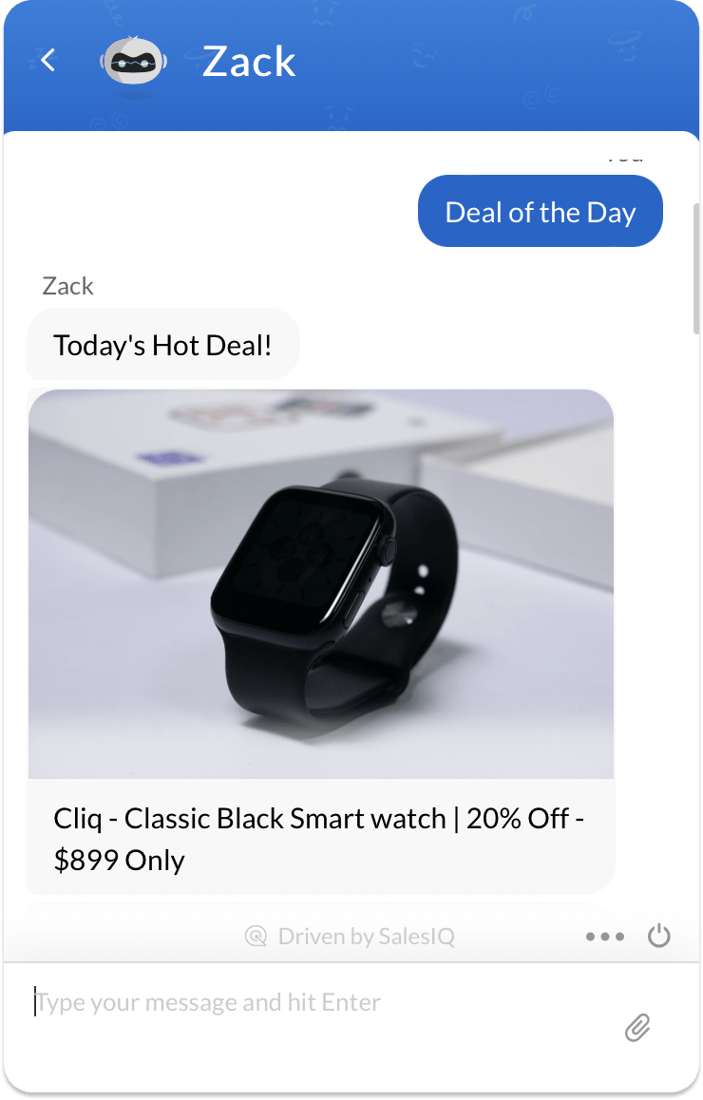

**One or more strings replies**

**//Syntax**

**response.put**

**("replies",**

**{"Text1","Text2"}**

**);**

**//Example**

**response.put**

**("replies",**

**{"Hi","Welcome to Zylker!"}**

**);**

**Delay replies**

**response.put("action","reply");**

**response.put("replies",**

**[**

**{**

**"text":"Welcome to Zylker",**

**"delay_config":**

**{**

**"enabled":true,**

**"info_messages":["Loading","Fetching slots"],**

**"type":"all",**

**"time":5**

**}**

**}**

**]);**

**//The "time" is given in seconds**

**//When more than one delay info messages are given. The "type" can be set as "random" or "all" to define the message order**

**Multiple maps - in case of display cards such as articles, images, and links**

**response.put("replies",{"Today's hot deal! ,**

**{**

**"text": "Cliq - Classic Black Smart watch", "20% Off - $899 Only"**

**"image": "http://zylker.com/cliq-classicblack.jpg/23454433445",**

**"image_position" : "fit|fill"**

**}**

**});**

**forward**

* When the bot is not trained to handle a visitor, it can forward the chat to a human operator.
* The bot can also forward the chat to a specific operator who is an expert in the topic.
* You can also add an info message indicating the status of the chat that the bot will display once the chat has been forwarded to the operator.

**Channel compatibility**

    

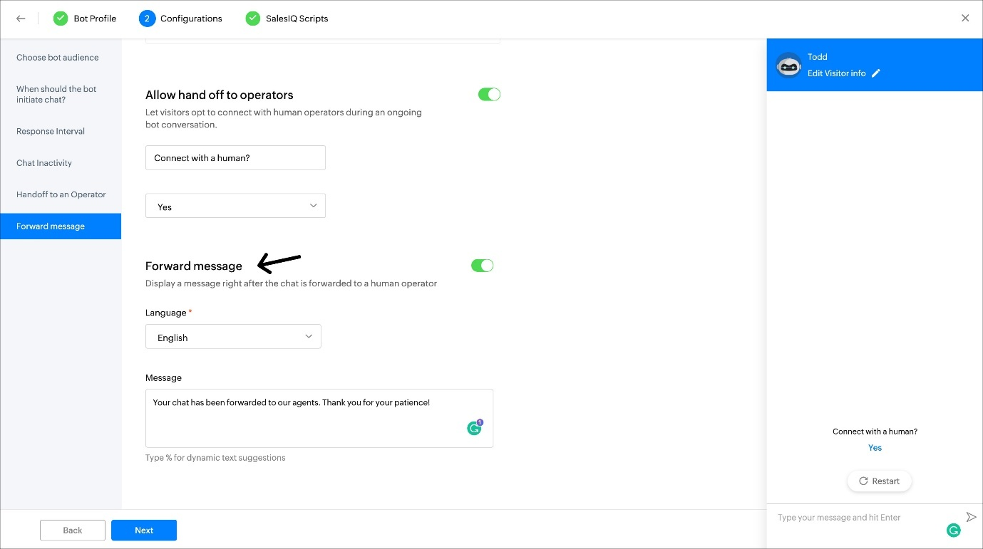

**Output**

**Web/MobileFacebookInstagramWhatsAppTelegramLINE**

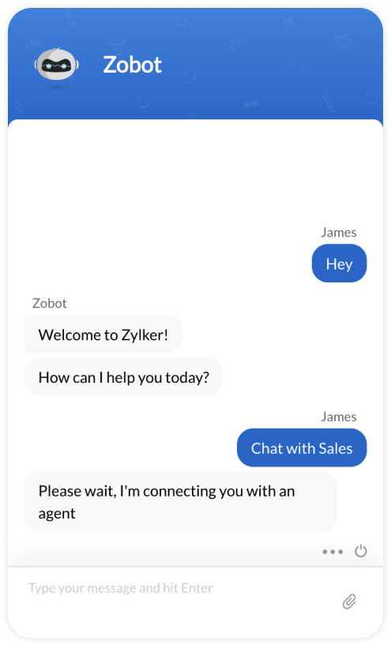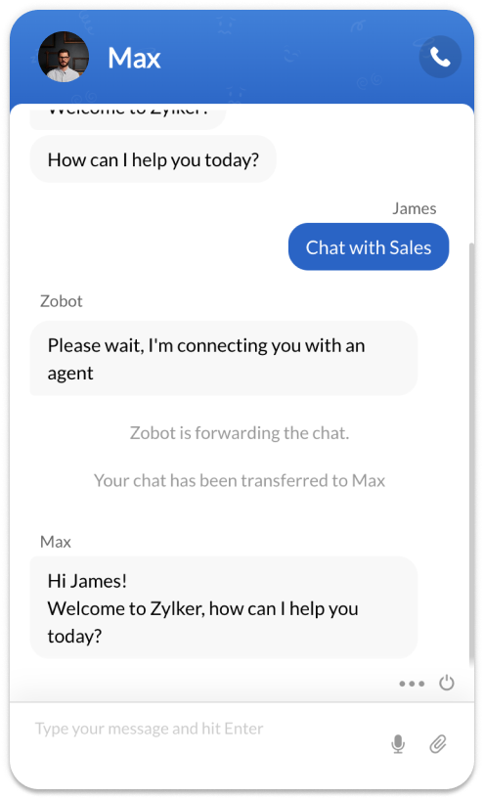

**Syntax:**

**{**

**"action" : "forward",**

**"replies" : ["Your text here"]**

**}**

**​{**

**"action" : "forward",**

**"replies" : ["Please wait, I'm connecting you to an agent"]**

**}**

**Use Case 2: Bot forwards the chat to a specific agent.**

**{**

**"action" : "forward",**

**"operators" : ["scott.fisher@zylker.com"],**

**"replies" : ["Sorry, I'm not sure I can help you with this question. Connecting you with an operator now.."]**

**}**

**Use Case 3: Bot forwards the chat to a specific department.**

**{**

**"action" : "forward",**

**"department" : "3465000000005",**

**"replies" : ["Sorry, I'm not sure I can help you with this question. Connecting you with an operator now.."]**

**}**

**operator_busy**

When the bot doesn't know how to handle the visitor and it also doesn't want to forward the chat to human operators (reasons may include non-business hours or all the operators are busy with another chat.), the operator_busy action is used. In this case, the visitor will be prompted to leave a message and the chat will be marked as missed.

**Channel compatibility**

      

**Output**

**Web/MobileFacebookInstagramWhatsAppTelegramLINE**

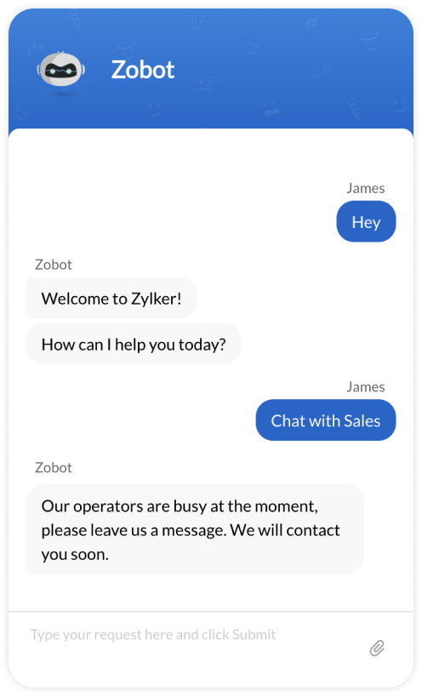

**Syntax:**

**{**

**"action" : "operator_busy" ,**

**"replies": [**

**"Your text here"**

**]**

**}**

**Use Case:**

**​{**

**"action" : "operator_busy" ,**

**"replies": [**

**"Our operators are busy at the moment, please leave us a message. We will contact you soon."**

**]**

**}**

**block**

The bot can find a vulnerability in the chat and it can block the IP of the visitor immediately.

**Channel compatibility**

      

**Output:**

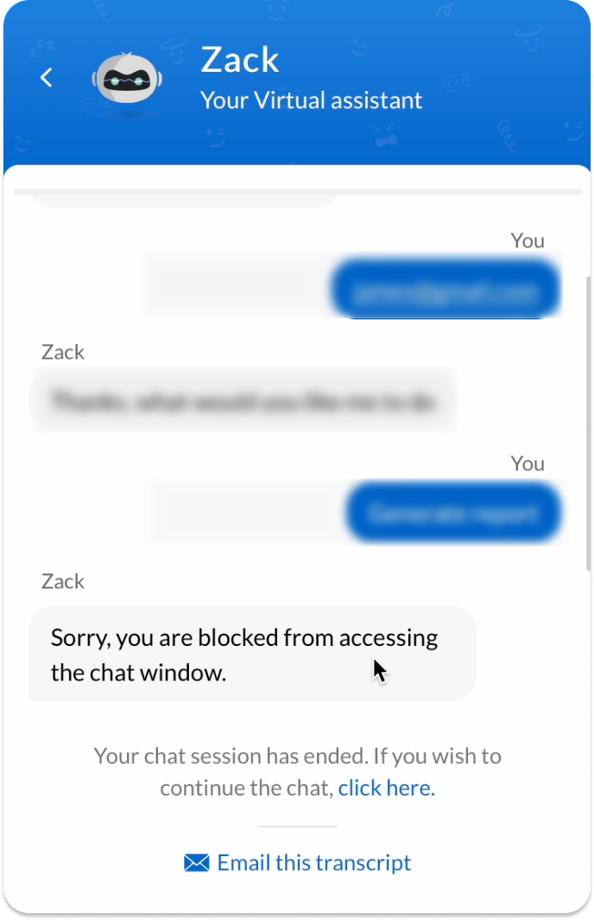

**Syntax:**

**{**

**​ "action" : "block" ,**

**"replies" : ["Your text here"]**

**}**

**Use Case:**

**{**

**​ "action" : "block" ,**

**"replies" : ["Sorry, you are blocked from accessing the chat window."]**

**}**

**context**

**When the bot wants to collect multiple inputs to perform one action, it returns a context.**

**Channel compatibility**

**    **

**Syntax:**

**{**

**"action": "context",**

**"context_id": "book_appointment",**

**"questions": {},**

**}**

**Use Case:**

**{**

**"action": "context",**

**"context_id": "book_appointment",**

**"questions": {**

**{**

**"name": "movie",**

**"replies": {**

**{**

**"text": "Ok, Lets make a booking with your sales execute !",**

**"icon": "https://zylker.com/meeting.jpg"**

**},**

**"Choose the department you would like to book appointment for ?"**

**},**

**"suggestions": {**

**"Books",**

**"SalesIQ",**

**"CRM"**

**}**

**},**

**{**

**"name": "show_timing",**

**"replies": {**

**"Thats a great movie to watch !",**

**"Choose the date for the show ?"**

**},**

**"input": {**

**"type": "calendar",**

**"time": "false",**

**"tz": "true"**

**}**

**}**

**}**

**}**

**pending**

**If a bot needs some time to reply to the visitor's message, the pending action can be used.**

**For example:**

* **When it tries to generate a report and send it to the visitor**
* **Or tries to create a profile for a visitor, which may take some time (but lesser than 3 mins).**

**A unique request ID will be available inside the request param in all the handlers. Once the pending action is returned by the bot, the request_id (found in the request object) sent in the param during execution will be used to handle the pending action. While the action is pending and the response is yet to be given, info messages can be sent to the visitor to show the progress of the pending action. During the pending action, the progress info and the response can be sent to the visitor using callback APIs.**[**Learn More**](https://www.zoho.com/salesiq/help/developer-section/pending-progress-v2.html)

**Channel compatibility**

**      **

**Output:**

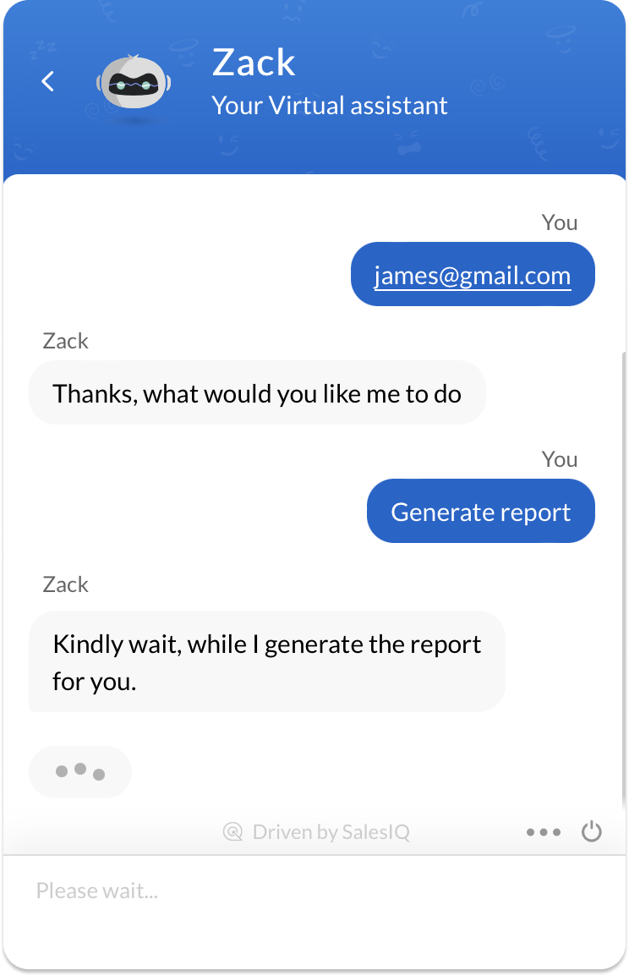**​**

**Syntax:**

**{**

**"action" : "pending",**

**"replies" : {"Your text here"}**

**}**

**Use Case:**

**{**

**"action" : "pending",**

**"replies" : ["Kindly wait, while I generate the report for you."]**

**}**

**end**

**To end the chat conversation.**

**Channel compatibility**

**Output**

**Web/MobileFacebookInstagramWhatsAppTelegramLINE**

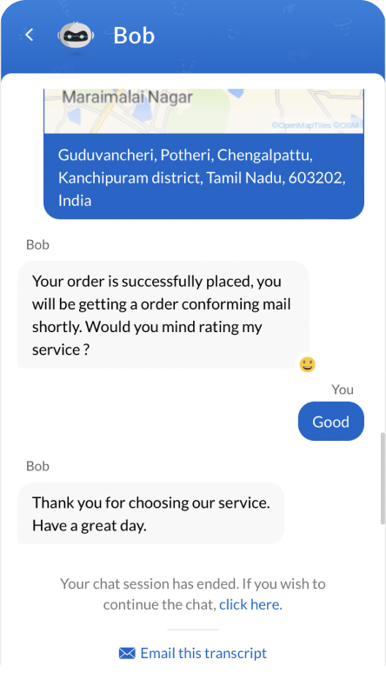

**Syntax:**

**{**

**"action": "end",**

**"replies" : ["Your text here"]**

**}**

**Use Case:**

**{**

**"action": "end",**

**"replies": ["Thank you for choosing our services", "Have a good day"]**

**}**

**Input**

**The Input Cards are the different type of actions used by the Zobots to procure the inputs from the visitors. input accepts only input cards as values. The following Input cards are available for use inside Zoho SalesIQ.**[**Learn more.**](https://www.zoho.com/salesiq/help/developer-guides/deluge-widgets.html)

* [**Happiness Rating**](https://www.zoho.com/salesiq/help/developer-guides/deluge-widgets-happiness-rating.html)
* [**Star Rating**](https://www.zoho.com/salesiq/help/developer-guides/deluge-widgets-star-rating.html)
* [**Like Button**](https://www.zoho.com/salesiq/help/developer-guides/deluge-widgets-like-button.html)
* [**Single Select Option**](https://www.zoho.com/salesiq/help/developer-guides/deluge-widgets-single-select-option.html)
* [**Multiple Select Option**](https://www.zoho.com/salesiq/help/developer-guides/deluge-widgets-multiple-select-option.html)
* [**Slider**](https://www.zoho.com/salesiq/help/developer-guides/deluge-widgets-slider-option.html)
* [**Range Slider**](https://www.zoho.com/salesiq/help/developer-guides/deluge-widgets-range-slider.html)
* [**Calendar**](https://www.zoho.com/salesiq/help/developer-guides/deluge-widgets-calendar.html)
* [**Range Calendar**](https://www.zoho.com/salesiq/help/developer-guides/deluge-widgets-range-calendar.html)
* [**Time Slot**](https://www.zoho.com/salesiq/help/developer-guides/deluge-widgets-time-slots.html)
* [**Date & Time Slots**](https://www.zoho.com/salesiq/help/developer-guides/deluge-widgets-date-time-slots.html)

**​**

**​​Example:**

**Copy**

**"input" :**

**{**

**{**

**"type" : "calendar"**

**}**

**}**

**Happiness Rating**

**This card can be used to get the visitors' ratings with smiles.**

|  |  |  |  |
| --- | --- | --- | --- |
| **Attributes** | **Mandatory** | **Description** | **Values** |
| **type** | **Yes** | **The type of input to be displayed to the visitor** | **happiness-rating** |
| **level** | **No** | **If you would like to handle the smileys using code, use the values below:**   * **:rating-angry:** * **:rating-sad:** * **:rating-neutral:** * **:rating-happy:** * **:rating-excited:** | **3 / 5** |
| **set_conversation_rating** | **No** | **To update the feedback on the**[**Feedback**](http://help.zoho.com/portal/en/kb/salesiq-2-0/for-administrators/feedback/articles/visitor-s-feedback)**sessions** | **true/false** |

**Note: The ratings will not be updated for the transferred and missed chats.**

**Channel compatibility and limitations**

**Facebook Messenger:**

* **The card is supported on Facebook.**
* **The users would get the ratings as single select options. They can choose an option to provide the rating.**

**Instagram:**

* **The card is supported on Instagram.**
* **When using this card, the users would get the ratings as single select options. They can choose an option to provide the rating.**

**WhatsApp:**

* **The card is supported on WhatsApp.**
* **When using this card, the rating will be given in the list format or single select options.**
* **If the rating number equals 3, all ratings will be listed as single select options.**
* **When the rating exceeds 3, all 5 ratings will be displayed in the list format.**

**Telegram:**

* **The card is supported on Telegram.**
* **When using this card, users get ratings as single select options. They can choose an option to provide the rating.**

**LINE:**

* **The card is supported on LINE.**
* **When using this card, users get ratings as single select options. They can choose an option to provide the rating.**

**Output**

**Web/MobileFacebookInstagramWhatsAppTelegramLINE**

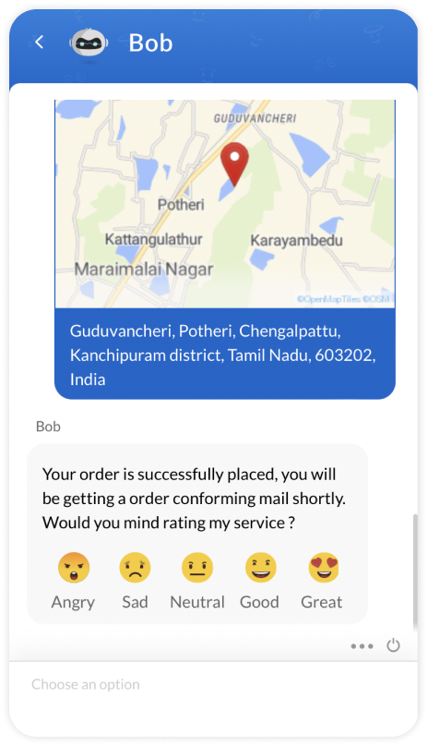

**Use Case**

**ScriptsZiaWebhookDialogflowWatsonAzure**

**{**

**"type": "happiness-rating",**

**"level": "5",**

**//Key for updating the rating in feedback section**

**"set_conversation_rating":true**

**}**

**Star Rating**

**This card helps the visitor get a rating from the stars.**

|  |  |  |  |
| --- | --- | --- | --- |
| **Attribute** | **Mandatory** | **Description** | **Values** |
| **type** | **Yes** | **The type of input to be displayed to the visitor** | **star-rating** |
| **level** | **No** | **The number of stars to be displayed to the visitor** | **3-10** |
| **set_conversation_rating** | **No** | **To update the feedback on the**[**Feedback**](http://help.zoho.com/portal/en/kb/salesiq-2-0/for-administrators/feedback/articles/visitor-s-feedback)**sessions** | **true/false** |

**Note:  The ratings will not be updated for the transferred and missed chats.**

**Channel compatibility and limitations**

**      **

**Facebook Messenger:**

* **The card is supported on Facebook.**
* **The users would get the ratings as single select options. They can choose an option to provide the rating.**

**Instagram:**

* **The card is supported on Instagram.**
* **When using this card, users get ratings as single select options. They can an choose option to provide the rating.**

**WhatsApp:**

* **The card is supported on WhatsApp.**
* **When using this card, the rating will be given in the list format or single select options.**
* **If the rating number equals 3, all ratings will be listed as options.**
* **When the rating exceeds 3, all 5 ratings will be displayed in the list format.**

**Telegram:**

* **The card is supported on Telegram.**
* **When using this card, users get ratings as single select options. They can choose an option to provide the rating.**

**LINE:**

* **The card is supported on LINE.**
* **When using this card, users get ratings as single select options. They can choose an option to provide the rating.**

**Output**

**Web/MobileFacebookInstagramWhatsAppTelegramLINE**

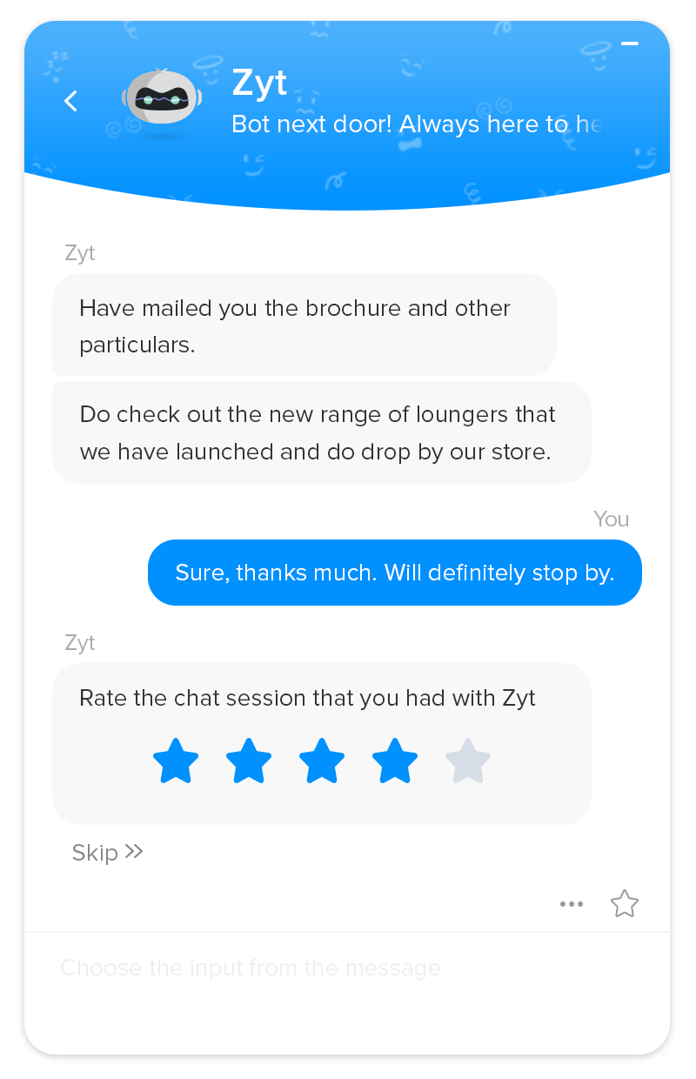

**Use Case**

**ScriptsZiaWebhookDialogflowWatsonAzure**

**{**

**"type": "star-rating",**

**"level": "5"**

**//Key for updating the rating in feedback section**

**"set_conversation_rating":true**

**}**

**Like Button for SalesIQ Scripts**

**This card can be used to collect feedback from the visitors via like/dislike (thumbs up / thumbs down) inputs format and update it in the**[**Feedback**](http://help.zoho.com/portal/en/kb/salesiq-2-0/for-administrators/feedback/articles/visitor-s-feedback)**section.**

|  |  |  |  |
| --- | --- | --- | --- |
| **Attribute** | **Mandatory** | **Description** | **Values** |
| **type** | **Yes** | **The type of the input to be displayed to the visitor** | **like** |

**Note:  The ratings will not be updated for the transferred and missed chats.**

**Output:**

**​**

**The above is an example of getting feedback by using like button.**

**Use Case:**

**{**

**"type": "like"**

**//Key for updating the rating in feedback section**

**"set_conversation_rating":true**

**}**

**Single select option**

**This card helps to get input from an options list. You can present the visitors with multiple options to get their responses. The main difference between a single select option card and a suggestion is that the suggestion can create multiple flows based on the visitors' response, whereas the options can be used to collect information from the visitors.**

|  |  |  |  |
| --- | --- | --- | --- |
| **Attribute** | **Mandatory** | **Description** | **Values** |
| **type** | **Yes** | **The type of input to be displayed to the visitor** | **select** |
| **options** | **Yes** | **An array of strings you would like to display as options** | **A maximum of 20 options in the array with a character limit of 80 each can be given.** |

**Channel compatibility and limitations**

**  **

**Facebook Messenger:**

* **The card is supported on Facebook.**
* **A maximum of 13 buttons (20 characters each) will be provided in a horizontal scrolling format.**
* **When more than 13 suggestions are provided, only the first 13 will be displayed.**
* **The characters exceeding more than 20 will be trimmed and only the first 20 characters will be displayed.**

**Instagram:**

* **The card is supported on Instagram.**
* **A maximum of 13 buttons (20 characters each) will be provided in a horizontal scrolling format.**
* **When more than 13 suggestions are provided, only the first 13 will be displayed.**
* **The characters exceeding more than 20 will be trimmed and only the first 20 characters will be displayed.**

**WhatsApp:**

* **The card is supported on WhatsApp.**
* **A maximum of 10 options (20 characters each) will be provided in a list format.**
* **If the option number is lesser than or equal to 3, all options will be listed as buttons.**
* **When more than 10 options are provided, only the first 10 will be displayed.**
* **The characters exceeding more than 20 will be trimmed and only the first 20 characters will be displayed.**

**Output**

**Web/MobileFacebookInstagramWhatsApp**

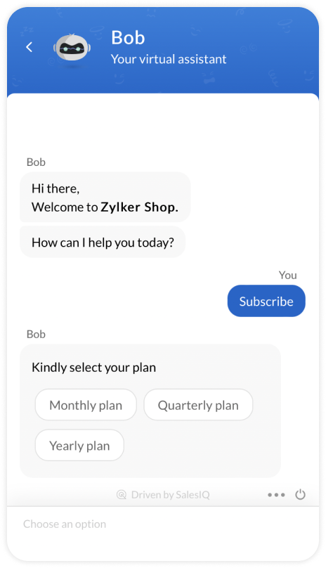

**Sample code**

**"user_defined": {**

**"zohosalesiq": {**

**"replies": [**

**"Kindly select your plan"**

**],**

**"input": {**

**"type": "select",**

**"options": [**

**"Monthly Plan",**

**"Quartey Plan",**

**"Yearly plan"**

**]**

**}**

**}**

**}**

**Multiple select options**

**This card allows collecting more than one option as input from the list of options provided. The card waits until the visitor picks the options and presses the submit button to send the input.**

|  |  |  |  |
| --- | --- | --- | --- |
| **Attribute** | **Mandatory** | **Description** | **Values** |
| **type** | **Yes** | **The type of input to be displayed to the visitor.** | **multiple-select** |
| **options** | **Yes** | **An array of strings you would like to display as options.** | **A maximum of 20 options in the array with a character limit of 80 each can be given.** |
| **max_selection** | **No** | **The maximum number of options allowed to be selected from the given options array.** | **A minimum (2) - maximum options can be set as per requirement.** |

**Channel compatibility and limitations**

**      **

**Facebook Messenger:**

* **The card is supported on Facebook.**
* **When using this card, the option would be listed in the bulletin, and the users have to type the options separated by a comma (,). Example: OnePlus Nord CE,OnePlus Nord 2**

**Instagram:**

* **The card is supported on Instagram.**
* **When using this card, the option would be listed in the bulletin, and the users have to type the options separated by a comma (,). Example: OnePlus Nord CE,OnePlus Nord 2**

**WhatsApp:**

* **The card is supported on WhatsApp.**
* **When using this card, the option would be listed in the bulletin, and the users have to type the options separated by a comma (,). Example: OnePlus Nord CE,OnePlus Nord 2**

**Telegram:**

* **The card is supported on Telegram.**
* **When using this card, the option would be listed in the bulletin, and the users have to type the options separated by a comma (,). Example: OnePlus Nord CE,OnePlus Nord 2**

**LINE:**

* **The card is supported on LINE.**
* **When using this card, the option would be listed in the bulletin, and the users have to type the options separated by a comma (,). Example: OnePlus Nord CE,OnePlus Nord 2**

**Output**

**Web/MobileFacebookInstagramWhatsAppTelegramLINE**

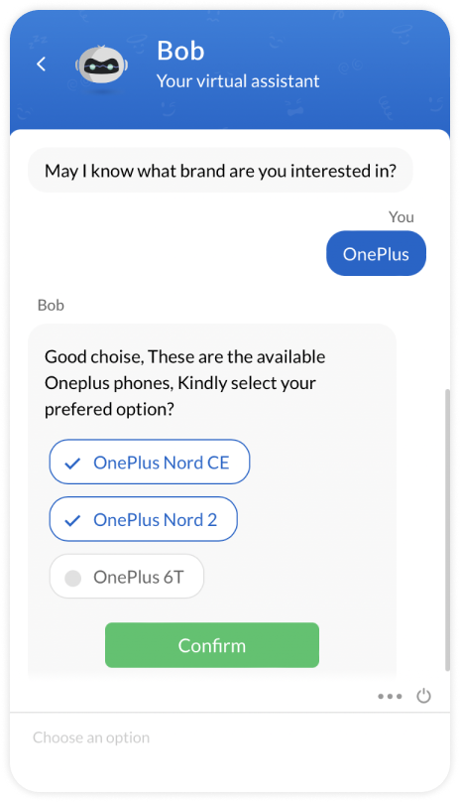

**Use Case**

**ScriptsZiaWebhookDialogflowWatsonAzure**

**{**

**"type": "multiple-select",**

**"options": [**

**"OnePlus Nord CE",**

**"OnePlus Nord 2",**

**"OnePlus 6T"**

**],**

**"min_selection":"1"**

**"max_selection": "2"**

**}**

* [**Introduction to Zobot**](https://www.zoho.com/salesiq/help/developer-guides/bot-introduction-2.0.html)
* [**Create a bot**](https://www.zoho.com/salesiq/help/developer-guides/create-bot-2.0.html)
* [**Edit/Delete a bot**](https://www.zoho.com/salesiq/help/developer-guides/edit-delete-bot-2.0.html)
* [**Enable/Disable a bot**](https://www.zoho.com/salesiq/help/developer-guides/enable-disable-bot-2.0.html)
* **Cards & Widgets**
  + [**Input Cards**](https://www.zoho.com/salesiq/help/developer-guides/deluge-input-widgets-siqscripts-2.0.html)
    - [**Happiness Rating**](https://www.zoho.com/salesiq/help/developer-guides/deluge-widgets-happiness-rating-siqscripts-2.0.html)
    - [**Star Rating**](https://www.zoho.com/salesiq/help/developer-guides/deluge-widgets-star-rating-siqscripts-2.0.html)
    - [**Single Select**](https://www.zoho.com/salesiq/help/developer-guides/deluge-widgets-single-select-option-siqscripts-2.0.html)
    - [**Multiple Select**](https://www.zoho.com/salesiq/help/developer-guides/deluge-widgets-multiple-select-option-siqscripts-2.0.html)
    - [**Slider**](https://www.zoho.com/salesiq/help/developer-guides/deluge-widgets-slider-option-siqscripts-2.0.html)
    - [**Range Slider**](https://www.zoho.com/salesiq/help/developer-guides/deluge-widgets-range-slider-siqscripts-2.0.html)
    - [**Calendar**](https://www.zoho.com/salesiq/help/developer-guides/deluge-widgets-calendar-siqscripts-2.0.html)
    - [**Range Calendar**](https://www.zoho.com/salesiq/help/developer-guides/deluge-widgets-range-calendar-siqscripts-2.0.html)
    - [**Location**](https://www.zoho.com/salesiq/help/developer-guides/deluge-widgets-location-siqscripts-2.0.html)
    - [**Time Slots**](https://www.zoho.com/salesiq/help/developer-guides/deluge-widgets-time-slots-siqscripts-2.0.html)
    - [**Date - Time Slots**](https://www.zoho.com/salesiq/help/developer-guides/deluge-widgets-date-time-slots-siqscripts-2.0.html)
    - [**Name**](https://www.zoho.com/salesiq/help/developer-guides/deluge-widgets-name-siqscripts-2.0.html)
    - [**Email**](https://www.zoho.com/salesiq/help/developer-guides/deluge-widgets-email-siqscripts-2.0.html)
    - [**Phone**](https://www.zoho.com/salesiq/help/developer-guides/deluge-widgets-phone-siqscripts-2.0.html)
    - [**URL**](https://www.zoho.com/salesiq/help/developer-guides/deluge-widgets-url-siqscripts-2.0.html)
    - [**Password**](https://www.zoho.com/salesiq/help/developer-guides/deluge-widgets-password-siqscripts-2.0.html)
    - [**Drop-down**](https://www.zoho.com/salesiq/help/developer-guides/deluge-widgets-drop-down-siqscripts-2.0.html)
    - [**Files**](https://www.zoho.com/salesiq/help/developer-guides/deluge-widgets-files-siqscripts.html)
  + [**Display Cards**](https://www.zoho.com/salesiq/help/developer-guides/deluge-display-widgets-siqscripts-2.0.html)
* [**Zobot Platforms**](https://www.zoho.com/salesiq/help/developer-guides/bot-integrations-2.0.html)
* [**Codeless bot builder**](https://help.zoho.com/portal/en/kb/salesiq-2-0/build-chatbots/codeless-bot-implementation-guide/articles/what-is-the-codeless-bot)
* [**SalesIQ Scripts**](https://www.zoho.com/salesiq/help/developer-guides/bot-siq-scripts-2.0.html)
* [**Zia Skills**](https://www.zoho.com/salesiq/help/developer-section/bot-zia-integration-2.0.html)
* [**Webhooks**](https://www.zoho.com/salesiq/help/developer-section/zobot-webhook-integration-2.0.html)
* [**Dialogflow**](https://www.zoho.com/salesiq/help/developer-section/bot-dialogflow-2.0.html)
* [**Watson Assistant**](https://www.zoho.com/salesiq/help/developer-section/ibm-watson-assistant-integration-2.0.html)
* [**Microsoft Azure**](https://www.zoho.com/salesiq/help/developer-section/msazure-integration-2.0.html)

**Slider option**

**This card helps to collect input from the visitor with a slider interface, i.e., they can choose a range starting from the first in the pre-defined range of inputs.**

|  |  |  |  |
| --- | --- | --- | --- |
| **Attribute** | **Mandatory** | **Description** | **Values** |
| **type** | **Yes** | **The type of input to be displayed to the visitor.** | **slider** |
| **values** | **Yes** | **An array of strings you would like to mark in the slider as options.** | **A maximum of 10 options in the array with a character limit of 10 each can be provided.** |

**Channel compatibility and limitations**

**      **

**Facebook Messenger:**

* **The card is supported on Facebook.**
* **When using this card, the range units/intervals would be given as a single select option for the users to select.**

**Instagram:**

* **The card is supported on Instagram.**
* **When using this card, the range units/intervals would be given as a single select option for the users to select.**

**WhatsApp:**

* **The card is supported on WhatsApp.**
* **A maximum of 10 range units/intervals (10 characters each) will be provided in a list format.**
* **If the units are lesser than or equal to 3, all units will be listed as single select options.**
* **When more than 10 units are provided, only the first 10 will be displayed.**
* **The characters exceeding more than 10 will be trimmed, and only the first 10 characters will be displayed.**

**Telegram:**

* **The card is supported on Telegram.**
* **When using this card, the range units/intervals would be given as a single select option for the users to select.**

**LINE:**

* **The card is supported on LINE.**
* **When using this card, the range units/intervals would be given as a single select option for the users to select.**

**Output**

**Web/MobileFacebookInstagramWhatsAppTelegramLINE**

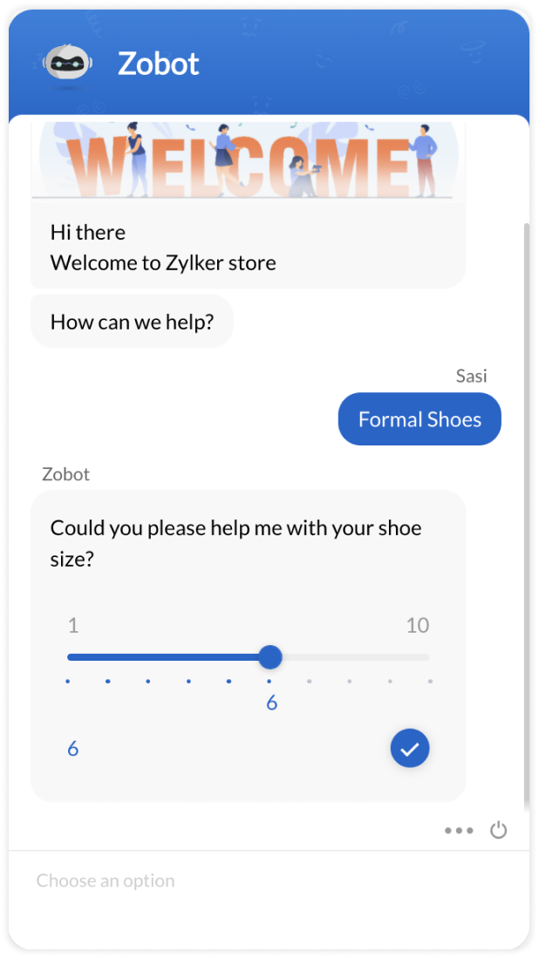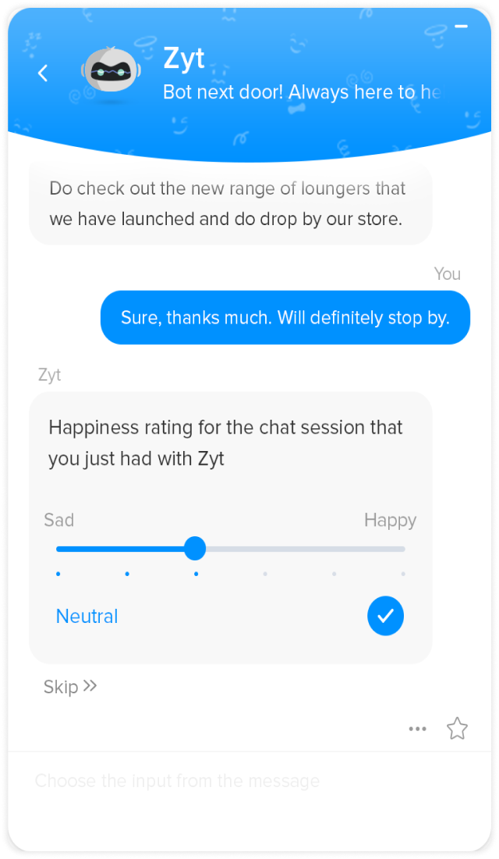

**Use Case**

**ScriptsZiaWebhookDialogflowWatsonAzure**

**//numbers in slider**

**{**

**"type": "slider",**

**"values": [**

**"1",**

**"2",**

**"3",**

**"4",**

**"5",**

**"6",**

**"7",**

**"8",**

**]**

**}**

**//string in slider**

**{**

**"type": "slider",**

**"values": [**

**"Sad",**

**"Neutral",**

**"Happy"**

**]**

**}**

**Range slider option**

**This card allows collecting the inputs as ranges from the visitor with a slider interface, i.e., they can choose from the first or start in between the slider and choose the range (Example: Visitors can pick the price range with the slider)**

|  |  |  |  |
| --- | --- | --- | --- |
| **Attribute** | **Mandatory** | **Description** | **Values** |
| **type** | **Yes** | **The type of input to be displayed to the visitor** | **slider** |
| **values** | **Yes** | **An array of strings you would like to mark in the slider as options** | **A maximum of 10 options in the array with a character limit of 10 each can be provided.** |

**Channel compatibility and limitations**

**      **

**Facebook Messenger:**

* **The card is supported on Facebook.**
* **When using this card, the slider range units/intervals will be listed in the bulletin, and the users will have to type their preferred range, separated by a hyphen (-). Example: 30000-80000**

**Instagram:**

* **The card is supported on Instagram.**
* **When using this card, the slider range units/intervals will be listed in the bulletin, and the users will have to type their preferred range, separated by a hyphen (-). Example: 30000-80000**

**WhatsApp:**

* **The card is supported on WhatsApp.**
* **When using this card, the slider range units/intervals will be listed in the bulletin, and the users will have to type their preferred range, separated by a hyphen (-). Example: 30000-80000**

**Telegram:**

* **The card is supported on Telegram.**
* **When using this card, the slider range units/intervals will be listed in the bulletin, and the users will have to type their preferred range, separated by a hyphen (-). Example: 30000-80000**

**LINE:**

* **The card is supported on LINE.**
* **When using this card, the slider range units/intervals will be listed in the bulletin, and the users will have to type their preferred range, separated by a hyphen (-). Example: 30000-80000**

**Output**

**Web/MobileFacebookInstagramWhatsAppTelegramLINE**

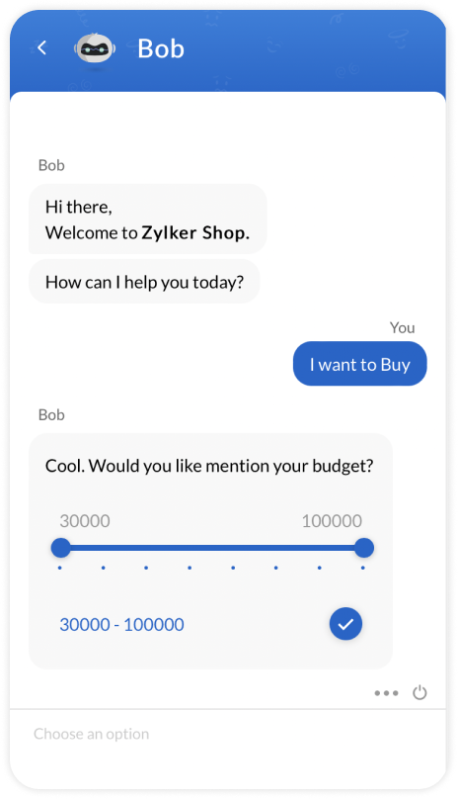

**Use Case**

**ScriptsZiaDialogflowWatsonAzure**

**{**

**"type": "range-slider",**

**"values": [**

**"30000",**

**"40000",**

**"50000",**

**"60000",**

**"70000",**

**"90000",**

**"100000"**

**]**

**}**

**Range slider option**

**This card allows collecting the inputs as ranges from the visitor with a slider interface, i.e., they can choose from the first or start in between the slider and choose the range (Example: Visitors can pick the price range with the slider)**

|  |  |  |  |
| --- | --- | --- | --- |
| **Attribute** | **Mandatory** | **Description** | **Values** |
| **type** | **Yes** | **The type of input to be displayed to the visitor** | **slider** |
| **values** | **Yes** | **An array of strings you would like to mark in the slider as options** | **A maximum of 10 options in the array with a character limit of 10 each can be provided.** |

**Channel compatibility and limitations**

**      **

**Facebook Messenger:**

* **The card is supported on Facebook.**
* **When using this card, the slider range units/intervals will be listed in the bulletin, and the users will have to type their preferred range, separated by a hyphen (-). Example: 30000-80000**

**Instagram:**

* **The card is supported on Instagram.**
* **When using this card, the slider range units/intervals will be listed in the bulletin, and the users will have to type their preferred range, separated by a hyphen (-). Example: 30000-80000**

**WhatsApp:**

* **The card is supported on WhatsApp.**
* **When using this card, the slider range units/intervals will be listed in the bulletin, and the users will have to type their preferred range, separated by a hyphen (-). Example: 30000-80000**

**Telegram:**

* **The card is supported on Telegram.**
* **When using this card, the slider range units/intervals will be listed in the bulletin, and the users will have to type their preferred range, separated by a hyphen (-). Example: 30000-80000**

**LINE:**

* **The card is supported on LINE.**
* **When using this card, the slider range units/intervals will be listed in the bulletin, and the users will have to type their preferred range, separated by a hyphen (-). Example: 30000-80000**

**Output**

**Web/MobileFacebookInstagramWhatsAppTelegramLINE**



**Use Case**

**ScriptsZiaDialogflowWatsonAzure**

**{**

**"type": "range-slider",**

**"values": [**

**"30000",**

**"40000",**

**"50000",**

**"60000",**

**"70000",**

**"90000",**

**"100000"**

**]**

**}**

* [**Introduction to Zobot**](https://www.zoho.com/salesiq/help/developer-guides/bot-introduction-2.0.html)
* [**Create a bot**](https://www.zoho.com/salesiq/help/developer-guides/create-bot-2.0.html)
* [**Edit/Delete a bot**](https://www.zoho.com/salesiq/help/developer-guides/edit-delete-bot-2.0.html)
* [**Enable/Disable a bot**](https://www.zoho.com/salesiq/help/developer-guides/enable-disable-bot-2.0.html)
* **Cards & Widgets**
  + [**Input Cards**](https://www.zoho.com/salesiq/help/developer-guides/deluge-input-widgets-siqscripts-2.0.html)
    - [**Happiness Rating**](https://www.zoho.com/salesiq/help/developer-guides/deluge-widgets-happiness-rating-siqscripts-2.0.html)
    - [**Star Rating**](https://www.zoho.com/salesiq/help/developer-guides/deluge-widgets-star-rating-siqscripts-2.0.html)
    - [**Single Select**](https://www.zoho.com/salesiq/help/developer-guides/deluge-widgets-single-select-option-siqscripts-2.0.html)
    - [**Multiple Select**](https://www.zoho.com/salesiq/help/developer-guides/deluge-widgets-multiple-select-option-siqscripts-2.0.html)
    - [**Slider**](https://www.zoho.com/salesiq/help/developer-guides/deluge-widgets-slider-option-siqscripts-2.0.html)
    - [**Range Slider**](https://www.zoho.com/salesiq/help/developer-guides/deluge-widgets-range-slider-siqscripts-2.0.html)
    - [**Calendar**](https://www.zoho.com/salesiq/help/developer-guides/deluge-widgets-calendar-siqscripts-2.0.html)
    - [**Range Calendar**](https://www.zoho.com/salesiq/help/developer-guides/deluge-widgets-range-calendar-siqscripts-2.0.html)
    - [**Location**](https://www.zoho.com/salesiq/help/developer-guides/deluge-widgets-location-siqscripts-2.0.html)
    - [**Time Slots**](https://www.zoho.com/salesiq/help/developer-guides/deluge-widgets-time-slots-siqscripts-2.0.html)
    - [**Date - Time Slots**](https://www.zoho.com/salesiq/help/developer-guides/deluge-widgets-date-time-slots-siqscripts-2.0.html)
    - [**Name**](https://www.zoho.com/salesiq/help/developer-guides/deluge-widgets-name-siqscripts-2.0.html)
    - [**Email**](https://www.zoho.com/salesiq/help/developer-guides/deluge-widgets-email-siqscripts-2.0.html)
    - [**Phone**](https://www.zoho.com/salesiq/help/developer-guides/deluge-widgets-phone-siqscripts-2.0.html)
    - [**URL**](https://www.zoho.com/salesiq/help/developer-guides/deluge-widgets-url-siqscripts-2.0.html)
    - [**Password**](https://www.zoho.com/salesiq/help/developer-guides/deluge-widgets-password-siqscripts-2.0.html)
    - [**Drop-down**](https://www.zoho.com/salesiq/help/developer-guides/deluge-widgets-drop-down-siqscripts-2.0.html)
    - [**Files**](https://www.zoho.com/salesiq/help/developer-guides/deluge-widgets-files-siqscripts.html)
  + [**Display Cards**](https://www.zoho.com/salesiq/help/developer-guides/deluge-display-widgets-siqscripts-2.0.html)
* [**Zobot Platforms**](https://www.zoho.com/salesiq/help/developer-guides/bot-integrations-2.0.html)
* [**Codeless bot builder**](https://help.zoho.com/portal/en/kb/salesiq-2-0/build-chatbots/codeless-bot-implementation-guide/articles/what-is-the-codeless-bot)
* [**SalesIQ Scripts**](https://www.zoho.com/salesiq/help/developer-guides/bot-siq-scripts-2.0.html)
* [**Zia Skills**](https://www.zoho.com/salesiq/help/developer-section/bot-zia-integration-2.0.html)
* [**Webhooks**](https://www.zoho.com/salesiq/help/developer-section/zobot-webhook-integration-2.0.html)
* [**Dialogflow**](https://www.zoho.com/salesiq/help/developer-section/bot-dialogflow-2.0.html)
* [**Watson Assistant**](https://www.zoho.com/salesiq/help/developer-section/ibm-watson-assistant-integration-2.0.html)
* [**Microsoft Azure**](https://www.zoho.com/salesiq/help/developer-section/msazure-integration-2.0.html)

**Range calendar card**

**This card helps to get the range of date & time as inputs from the visitors using a calendar widget. The visitor can choose a range of date & time with this card.**

|  |  |  |  |  |
| --- | --- | --- | --- | --- |
| **Attribute** | **Mandatory** | **Description** | **Values** | |
| **type** | **Yes** | **The type of input to be displayed to the visitor** | **range-calendar** | |
| **time** | **No** | **You can specify that either the calendar should display only the date or time along with the date.** | **true - To allow the visitor to choose the time value along with the ate** | |
| **from** | **No** | **Specifies the minimum date range from which the visitors are allowed to choose the date, i.e., the onset date the visitors are allowed to select from the calendar.** | **+/- Integer** | **The no. of days to be specified in the calendar will be calculated before and after the present day.** |
| **For Example:**  **+5 - This will calculate 5 days after the present-day -3 - This will calculate days before the present-day** |
| **Long** | **The date value is specified in milliseconds** |
| **For Example:**  **123232323 - start date/time specified in the calendar 121212133 - end date/time specified in the calendar** |
| **to** | **No** | **Specifies the maximum date range from where the visitors are allowed to choose the date, i.e., the latest date the visitors are allowed to select from the calendar.** | **+/- Integer** | **The no. of days to be specified in the calendar will be calculated before and after the present day.** |
| **For Example:**    **+5 - This will calculate 5 days after the present-day -3 - This will calculate days before the present-day** |
| **Long** | **The date value is specified in milliseconds** |
| **For Example:**  **123232323 - start date/time specified in the calendar 121212133 - end date/time specified in the calendar** |
| **tz** | **No** | **Specifies whether the visitor chooses the timezone in the calendar** | **true - To allow the visitor to choose the timezone in the calendar. If not specified, then the timezone of the visitor's device will be taken by default.** | |
| **select_label** | **No** | **To set customized text for widget values/slot submission actions** | **Instead of 'Schedule', they can use custom text like 'Choose a slot"**  **Note: Maximum character limit for values passed inside the select_label key is 20** | |
| **time_format** | **No** | **To set the time format (12 hrs/ 24 hrs) of calendar** | **"12" or "24" // 12 hrs format is default** | |

**Channel compatibility and limitations**

**      **

**Facebook Messenger:**

* **The card is supported on Facebook.**
* **When using this card, the user would have to type the date/time manually.**
* **The "Change timezone" allows the user to change the timezone.**

**Instagram:**

* **The card is supported on Instagram.**
* **When using this card, the user would have to type the date/time manually.**
* **The "Change timezone" allows the user to change the timezone.**

**WhatsApp:**

* **The card is supported on WhatsApp.**
* **When using this card, the user would have to type the date/time manually.**
* **The "Change timezone" allows the user to change the timezone.**

**Telegram:**

* **The card is supported on Telegram.**
* **When using this card, the user would have to type the date/time manually.**
* **The "Change timezone" allows the user to change the timezone.**

**LINE:**

* **The card is supported on LINE.**
* **When using this card, the user would have to type the date/time manually.**
* **The "Change timezone" allows the user to change the timezone.**

**Output**

**Web/MobileFacebookInstagramWhatsAppTelegramLINE**



**Case 1: Time limit is relative. The date range from where the visitor can choose a date is calculated by +/- integer from the present-day.**

**ScriptsZiaWebhookDialogflowWatsonAzure**

**{**

**"type": "range-calendar",**

**"time": true,**

**"tz": true,**

**"from": "-5",**

**"label": "Schedule a meeting",**

**"to": "+5",**

**"select_label": "Choose a slot"**

**}**

**Case 2: Time limit is absolute. The date range (fromtime to totime)is calculated in millisecond and visitor can pick the date from the ample calendar.**

**{**

**"type": "range-calendar",**

**"time": true,**

**"tz": true,**

**"from": "12121212",**

**"label": "Schedule a meeting",**

**"to": "1212121",**

**"select_label": "Choose a slot"**

**}**

**Time slots**

**This card helps to get time as input by displaying the list of time slots in the window and allowing the visitor to pick one from the given slots.**

|  |  |  |  |
| --- | --- | --- | --- |
| **Attribute** | **Mandatory** | **Description** | **Values** |
| **type** | **Yes** | **The type of input to be displayed to the visitor** | **timeslots** |
| **slots** | **Yes** | **Specify the array of time slots in hh:mm (24 hrs) format that you would like to display** | **[hh:mm, hh:mm]** |
| **tz** | **No** | **Specify to allow the visitor to choose the timezone in the calendar** | **true - To allow the visitor to choose the timezone in the calendar. If not specified, then the timezone of the visitor's device will be taken by default.** |
| **date** | **Yes** | **Specify to allow the visitor to choose the date in the calendar** | **dd/mm/yyyy** |
| **time_zone_id** | **Yes** | **time_zone_id from the java.util. TimeZone class is valid** | **"Asia/Calcutta"** |

**Channel compatibility and limitations**

**      **

**Facebook Messenger:**

* **The card is supported on Facebook.**
* **When using this card, the user would have to type the date/time manually.**

**Instagram:**

* **The card is supported on Instagram.**
* **When using this card, the user would have to type the date/time manually.**

**WhatsApp:**

* **The card is supported on WhatsApp.**
* **When using this card, the user would have to type the date/time manually.**

**Telegram:**

* **The card is supported on Telegram.**
* **When using this card, the user would have to type the date/time manually.**

**LINE:**

* **The card is supported on LINE.**
* **When using this card, the user would have to type the date/time manually.**

**Output**

**Web/MobileFacebookInstagramWhatsAppTelegramLINE**

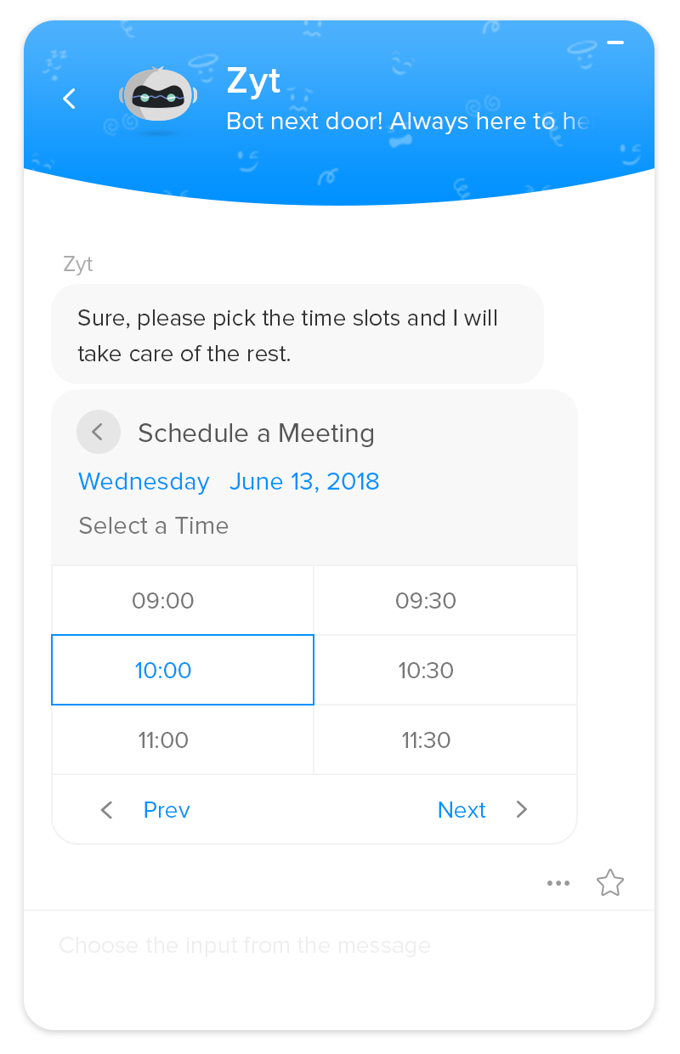

**Use Case**

**ScriptsZiaWebhookDialogflowWatsonAzure**

**{**

**"type": "timeslots",**

**"tz": true,**

**"label": "Schedule a meeting",**

**"date": "23/01/2024",**

**"time_zone_id": "Asia/Calcutta",**

**"slots": [**

**"09:00",**

**"10:00",**

**"11:00",**

**"01:00",**

**"03:00"**

**]**

**}**

**Time slots**

**This card helps to get time as input by displaying the list of time slots in the window and allowing the visitor to pick one from the given slots.**

|  |  |  |  |
| --- | --- | --- | --- |
| **Attribute** | **Mandatory** | **Description** | **Values** |
| **type** | **Yes** | **The type of input to be displayed to the visitor** | **timeslots** |
| **slots** | **Yes** | **Specify the array of time slots in hh:mm (24 hrs) format that you would like to display** | **[hh:mm, hh:mm]** |
| **tz** | **No** | **Specify to allow the visitor to choose the timezone in the calendar** | **true - To allow the visitor to choose the timezone in the calendar. If not specified, then the timezone of the visitor's device will be taken by default.** |
| **date** | **Yes** | **Specify to allow the visitor to choose the date in the calendar** | **dd/mm/yyyy** |
| **time_zone_id** | **Yes** | **time_zone_id from the java.util. TimeZone class is valid** | **"Asia/Calcutta"** |

**Channel compatibility and limitations**

**      **

**Facebook Messenger:**

* **The card is supported on Facebook.**
* **When using this card, the user would have to type the date/time manually.**

**Instagram:**

* **The card is supported on Instagram.**
* **When using this card, the user would have to type the date/time manually.**

**WhatsApp:**

* **The card is supported on WhatsApp.**
* **When using this card, the user would have to type the date/time manually.**

**Telegram:**

* **The card is supported on Telegram.**
* **When using this card, the user would have to type the date/time manually.**

**LINE:**

* **The card is supported on LINE.**
* **When using this card, the user would have to type the date/time manually.**

**Output**

**Web/MobileFacebookInstagramWhatsAppTelegramLINE**



**Use Case**

**ScriptsZiaWebhookDialogflowWatsonAzure**

**{**

**"type": "timeslots",**

**"tz": true,**

**"label": "Schedule a meeting",**

**"date": "23/01/2024",**

**"time_zone_id": "Asia/Calcutta",**

**"slots": [**

**"09:00",**

**"10:00",**

**"11:00",**

**"01:00",**

**"03:00"**

**]**

**}**

**Suggestions**

**Response suggestions can be given by the bot in order to save the time and trouble of typing for visitors. This card can be used to display suggestions and route the bot conversation based on the selected suggestion.**

* **Suggestions are a list, you can stack more than one suggestion.**
* **Suggestions only accept collection as the value.**
* **The collection, in turn, must only have a list of strings separated by a comma.**
* **There is no limit to suggestions.**

**Channel compatibility and limitations**

**      **

**Facebook Messenger:**

* **The card is supported on Facebook.**
* **A maximum of 13 buttons (20 characters each) will be provided in a horizontal scrolling format.**
* **When more than 13 suggestions are provided, only the first 13 will be displayed.**
* **The characters exceeding more than 20 will be trimmed, and only the first 20 characters will be displayed.**

**Instagram:**

* **The card is supported on Instagram.**
* **A maximum of 13 buttons (20 characters each) will be provided in a horizontal scrolling format.**
* **When more than 13 suggestions are provided, only the first 13 will be displayed.**
* **The characters exceeding more than 20 will be trimmed, and only the first 20 characters will be displayed.**

**WhatsApp:**

* **The card is supported on WhatsApp.**
* **A maximum of 10 buttons (20 characters each) will be provided in a list format.**
* **If the suggestion number is lesser than or equal to 3, all suggestions will be listed as buttons.**
* **When more than 10 suggestions are provided, only the first 10 will be displayed.**
* **The characters exceeding more than 20 will be trimmed, and only the first 20 characters will be displayed.**

**Telegram:**

* **The card is supported on Telegram.**
* **A maximum of 20 buttons (40 characters each) will be provided in a horizontal scrolling format.**
* **When more than 20 suggestions are provided, only the first 20 will be displayed.**
* **The characters exceeding 40 will be trimmed, and only the first 40 characters will be displayed.**

**LINE:**

* **The card is supported on LINE.**
* **A maximum of 13 buttons (20 characters each) will be provided in a horizontal scrolling format.**
* **When more than 13 suggestions are provided, only the first 13 will be displayed.**
* **The characters exceeding 20 will be trimmed, and only the first 20 characters will be displayed.**

**Output**

**Web/MobileFacebookInstagramWhatsAppTelegramLINE**

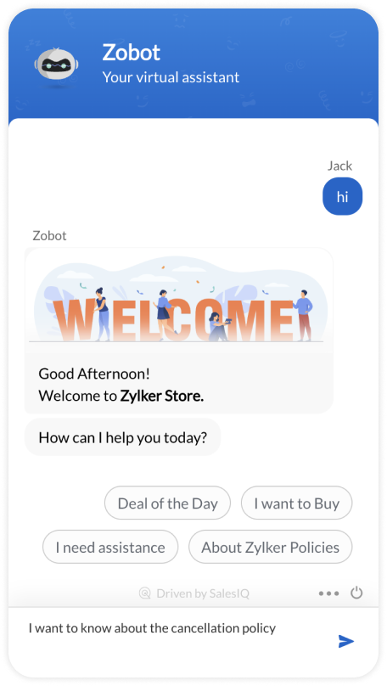

**Syntax**

**{**

**"suggestions": [**

**"Suggestion1",**

**"Suggestion2",**

**"Suggestion3"**

**]**

**}**

**Sample Code**

**{**

**"action": "reply",**

**"replies": [**

**"How can we help?",**

**],**

**"suggestions": [**

**"Deal of the day,**

**"Just browsing",**

**"I need assistance",**

**"About Zylker Policies"**

**]**

**}**

**Validation ​**

**To validate the info provided by the visitors. You can validate the following input fields:**

* **email - To validate the email address given by the visitor.**
* **phoneno - To validate the phone number provided.**
* **website - To validate the website address provided.**
* **number - To validate the number or to allow just numbers in the field.**
* **number(n-m) - To validate the number and you can also specify the "from" and "to" range of the number allowed.**
* **string(n-m) - If the visitor's answer contains a number or other special characters, the Zobot will not validate it. It is only valid if the answer contains alphabetical characters with no space within a given range.**
* **decimal - Precision is the number of digits in a number. Scale is the number of digits to the right of the decimal point in a number. For example, the number 123.45 has a precision of 5 and a scale of 2.**
* **text - If the visitor's answer's length is greater than or less than the given limit, the Zobot will not accept the answer as valid.  Note: It includes every character in the answer.**

**​Note: To mention the error message is your choice. If you skip "error", then the question will repeat without the error message until the visitor input is valid.**

**Channel compatibility**

**  **

**Output:**

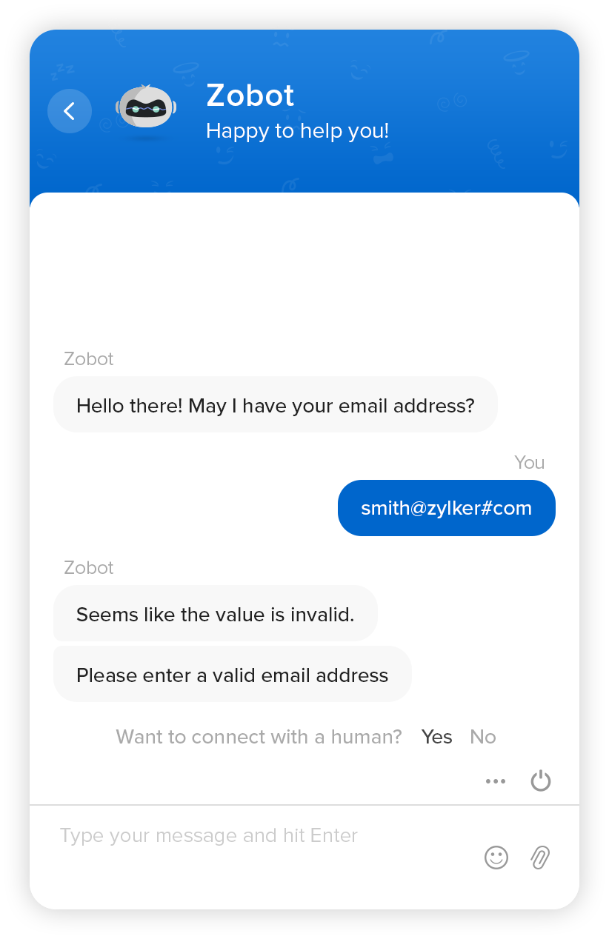**​**

**Sample Code:**

**{**

**"text": "Hello there! May I have your email address, please? ",**

**"validate": {**

**"format": "email",**

**"error": {"Seems like the value is invalid.","Please enter a valid email address"}**

**}**

**}**